Contents

Table of Contents

1. Day-1 2

1.1.Time Boxing 2

1.2. Email Usage & Mail Attachments 3

1.3. Meeting Invitation & Google Meet Sharing 3

1.4. Google Calendar 4

1.5. Hangouts 4

1.6. Mail Chaining 4

1.7. Outlook 5

1.8. File Naming Conventions 5

1.9. Ms-Word 5

1.10. Google Drive 6

2. Ms-Excel 7

2.1. Basics of Excel 7

2.2. Entering Data 7

2.3 Insert rows and columns. 7

2.4 Merge and unmerge. 7

2.5 Group and ungroup of rows and columns 7

2.6 Freeze and Unfreeze of data. 7

2.7 Insert Formulas 7

2.8 Inserting Graphs and charts 8

2.9 Sorting 8

2.10 Insert Dates 8

3. Project SRM Project Plan PPT 8

4. Manager Expectation PPT 8

4.1 Design Documents Preparation for SW 8

4.2. Do’s and Don’ts 9

**Index**:

| **S.No** | **topic of study** | **start of date** | **end of date** | **status** |
| --- | --- | --- | --- | --- |
|  | **Timeboxing, Email usage & mail attachment, Meeting Invitation & google meet sharing, calendars, Hangouts, Mail Chaining, Outlook, File Naming Conventions, Ms-word, Google Drive.** | **17/10/23** | **18/10/23** | **Completed** |
| **2.** | **Ms-Excel** | **19/10/23** | **19/10/23** | **Completed** |
| **3.** | **Project SRM Project Plan** | **19/10/23** | **19/10/23** | **Completed** |
| **4.** | **Manager's Expectation PPT** | **19/10/23** | **19/10/23** | **Completed** |
| **5.** | **MS-PPT** | **20/10/23** | **20/10/23** | **Completed** |
| **6.** | **Productivity/Quality tools** | **20/10/23** | **20/10/23** | **Completed** |
| **7.** | **4 Blockers PPT** | **20/10/23** | **20/10/23** | **Completed** |
| **8.** | **SDLC Process and V-Model** | **20/10/23** | **20/10/23** | **Completed** |

TimeBoxing**,** Email Usage & Mail Attachments**,** Meeting Invitation & Google Meet Sharing**,** Google Calendar**,** Hangouts**,** Mail Chaining**,** Outlook**,** File Naming Conventions**,** Ms-

**Date :17-10-23**

# Day-1

## 1.1.Time Boxing

Time Boxing means setting a fixed amount of time in your

calendar for a particular task. We have to fix tasks which we are going to do and update the time boxing status everyday before starting the day.

We split the tasks with 2 hours of time to learn.

Example:

Good Morning Sir,This is Hari Chandana.

Task planning @18/10/23,

1). Mail Chaining----------------10:00am to 11:00 am.

2). Outlook ---------------------11:00am to 12:00pm.

3). File Naming Conventions -----12:00pm to 1:20pm.

4). Meeting with Mentor---------- 2:00pm to 2:20pm

4). MS word Learning

a)understanding doc with index & standard SRM template.----2:20 pm to 3:00pm

b)header, footer & page no--------3:00pm to 3:30pm

c)text alignment & text format----3:30pm to 4:30pm

d)prepare study document----------4:30pm to 5:30pm

5). Google Drive --5:30pm to 7:00pm.

This is how we organize our tasks and update the time boxing accordingly.

## 1.2. Email Usage & Mail Attachments

Email is used to communicate with others via mail. Emails are mainly to send valid and professional information. Here we can send the attachments (Documents).

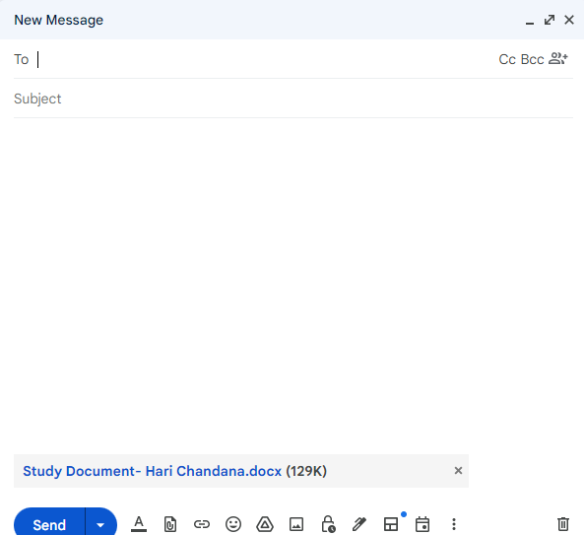

We can attach documents and send the documents to recipients.

## 1.3. Meeting Invitation & Google Meet Sharing

Creating the Google meet invitations to review and checking the progress of our tasks. Creating google meets on a particular date and time daily or weekly or monthly. And we can share the google meeting through the links.

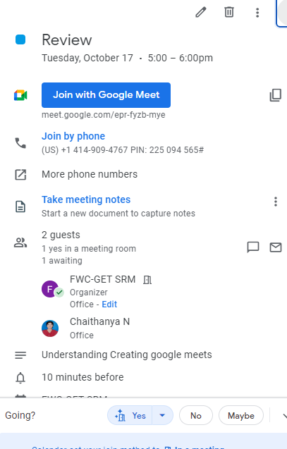

We can invite or create a meeting by use google meet or google calendars on a particular date and time.

## 1.4. Google Calendar

To set reminders on a particular date or particular time. And note the day wise status to know our status shortly.

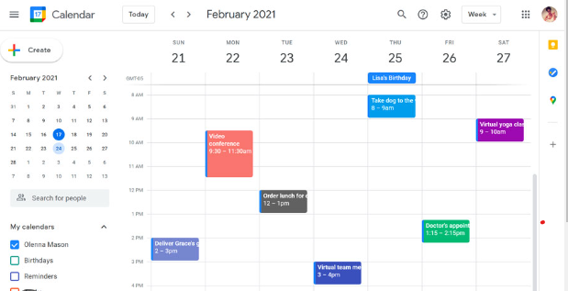

## 1.5. Hangouts

Communicating with a purpose, we use Hangouts or google chats. It is used to communicate in short ways and share the media directly in chats.

**Date: 18-10-23**

## 1.6. Mail Chaining

You need to reply to the same mail daily and it’s a loop-like process. Mail chain messages are encrypted end-to-end.

## 1.7. Outlook

Outlook facilitates email communication, organizing contact lists as well as using the calendar feature for setting up meetings and other events.

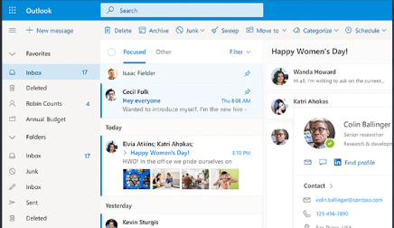

Outlook is very similar to gmail. Here we send and receive email through it.

## 1.8. File Naming Conventions

File naming conventions help you stay organized and quickly identify your files.

## 1.9. Ms-Word

* In MS Word I have learnt about how to create a template, font formatting, paragraph formatting, page formatting, header, footer, page numbers, and how to maintain SRM Study document.
* **Paragraph formatting**

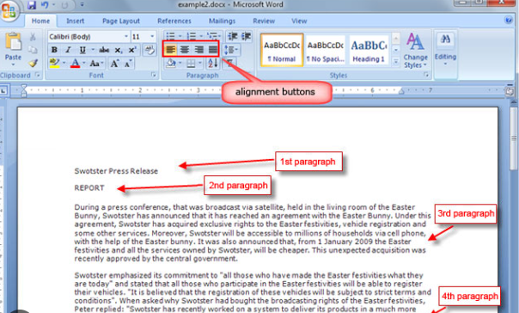

* **Head, Footer and page numbers**

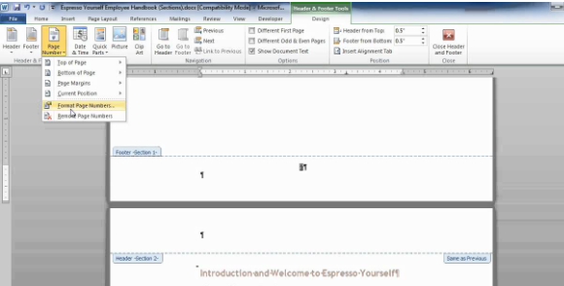

* **SRM Study document**

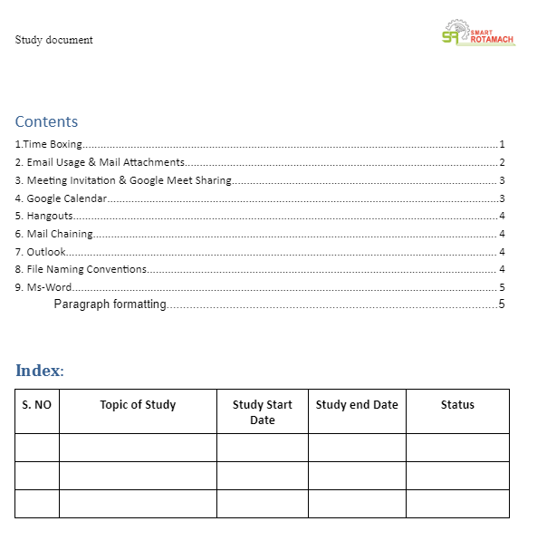We have to maintain a SRM study document with SRM Logo and credentials on every page is mandatory.

## 1.10. Google Drive

* We can create files in the drive which can be accessible from anywhere.
* We can upload files in it and store the files then we cannot lose them.
* 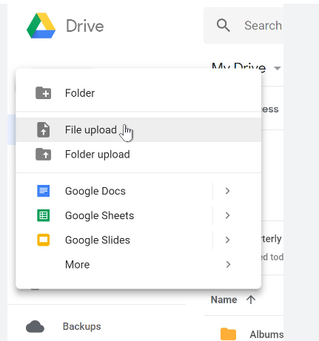

**Date: 19-10-23**

# Ms-Excel

## 2.1. Basics of Excel

* Grid, Ribbon
* Adding sheets, renaming sheets, deleting sheets, Zooming option.

## 2.2. Entering Data

* How to enter data into cells
* Auto fit – by dragging, by double clicking.
* Keyboard navigation
* Right – right arrow or tab
* Left – left arrow or shift tab
* Up – up arrow or shift+enter.
* Down – down arrow or enter.
* Numbers are automatically at the right side and text is aligned at left side.

## 2.3 Insert rows and columns.

* Right click and select insert to add column and rows.
* Select and right click and then delete we can delete rows and columns

## 2.4 Merge and unmerge.

* By using merge and centre option in home ribbon we can merge and unmerge cellsA screenshot of a computer

  Description automatically generated

## 2.5 Group and ungroup of rows and columns

* By using group and ungroup options in the data ribbon we can hide and unhide data in rows and columns.

## 2.6 Freeze and Unfreeze of data.

* By using the freeze panes option in view ribbon we can freeze the first column and first row.

## 2.7 Insert Formulas

* By using = and entering formulas we get the result of the formulas.

## 2.8 Inserting Graphs and charts

* After selecting columns and rows for creating bar graphs and charts then select alt+F1 or go to insert ribbon and select graph.
* We can change the chart type by right clicking and selecting change chart type.

## 2.9 Sorting

* For sorting data go to home ribbon and select sort filter then we can filter data A-Z or Z-A or highest to lowest or lowest to highest.

## 2.10 Insert Dates

* Enter date and go to home ribbon then select series and then select column+date+weekdays and then enter stop date we get dates serially
* Today date - Ctrl+;
* Present time – Ctrl+shift+;
* Series -   Alt+H+F+I+S

# Project SRM Project Plan

G-drive Link of project plan for College Project

<https://docs.google.com/spreadsheets/d/1OoreFc-h07jjWhejC8u8srolxYfAhYU7/edit#gid=262640827>

# Manager Expectation PPT

* Scope of work
* Study and analyze design and technology.
* System requirements
* Maintain SRS/SDD/STP/STR documents for software.
* Maintain SyRS/HDD/HTP/HTR for hardware.
* Peer Review
* Manager Review.
* Deliverables: Defect matrix update, Logging issues in GIT
* Releasing the design document in Git

## 4.1 Design Documents Preparation for SW

These are the steps for document preparation for SW.

## 4.2. Do’s and Don’ts

Here we have Do’s and Don’ts,

* When we are preparing block diagram.
* When comparing 2 Results/Waveforms.
* When preparing comparison Excel.

# MS PPT

**Date: 20-10-23**

* By using Insert ribbon we can add pictures, shapes, text boxes…etc
* By using format ribbon we can change the format.
* We can change font and font colour in home ribbon.
* Drawing fish bone diagram using PPT is done.

## 5.1 fishbone diagram

* Fishbone diagram helps to find the root cause of the problem.
* To Resolve the problem first time.

**Steps for fishbone diagram:**

1. State the problem.
2. Define your Category.
3. Brainstorm each category.
4. Analyze the problem.

**Fishbone Diagram of washing machine repair**.

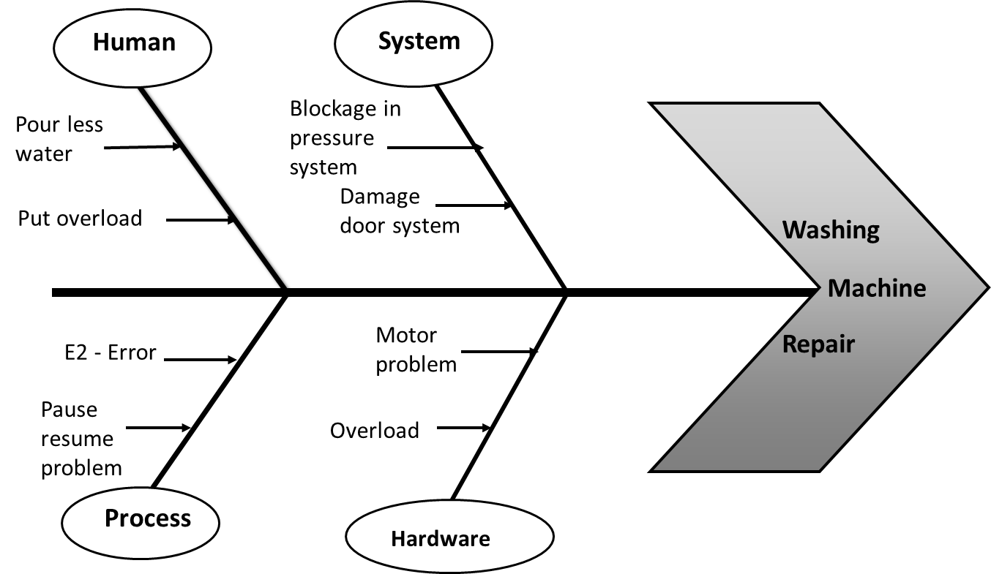

G-drive link of FishBone diagram PPT–

<https://docs.google.com/presentation/d/1OkHlRwhfePVrBHsKDOcOn1Aw5ms-Wx0p/edit#slide=id.p1>

# 6. Productivity/quality tools

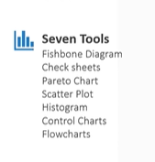

## 6.1 Cause and Effect Diagram

* This is also called as FishBone Diagram.
* This diagram shows the main causes of a problem.
* It helps to find the root cause of the problem.

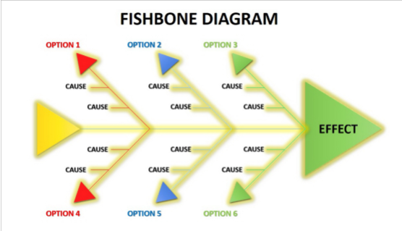

## 6.2 Flow Chart

* A flowchart is a type of [diagram](https://en.wikipedia.org/wiki/Diagram) that represents a [workflow](https://en.wikipedia.org/wiki/Workflow) or [process](https://en.wikipedia.org/wiki/Process).
* A flowchart can also be defined as a diagrammatic representation of an [algorithm](https://en.wikipedia.org/wiki/Algorithm), a step-by-step approach to solving a task.

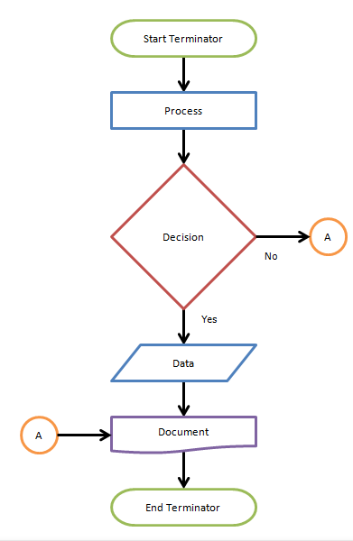

## 6.3 Check Sheet

It was used to collect data in easy format.data should be collected from the same person/ location.data collection should be based on actual facts collecting the data from pattern of events,defects, defect location. It is during the review process.

## 6.4 Pareto Chart

* Pareto is a chart that contains both bar chart and line chart. Individual values are represented in bar chart and cumulative total is represented in line chart.
* It follows 80-20 rule. That means 20% causes leads to 80% effects.

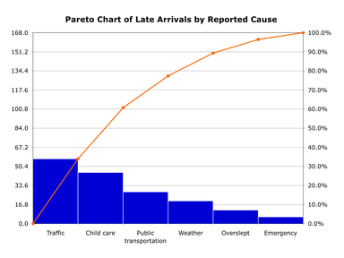

## 6.5 Scatter plot

* The purpose of the scatter plot is to display what happens to one variable when another variable is changed.
* Scatter plots are the graphs that present the relationship between two variables in a data-set.

## 6.6 Histogram

* Histogram is a bar graph representing the frequency distribution.
* A bar graph is the graphical representation of categorical data using rectangular bars where the length of each bar is proportional to the value they represent.
* A histogram is the graphical representation of data where data is grouped into continuous number ranges and each range corresponds to a vertical bar.

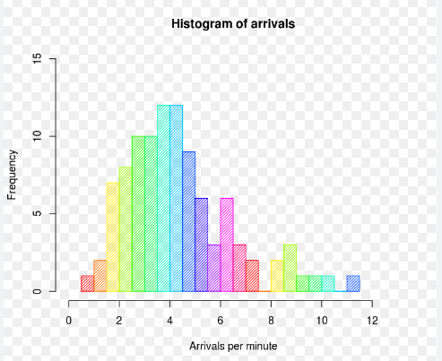

## 6.7 Control Chart

* The control chart is a graph used to study how a process changes over time.
* By using this, we can conclude whether the process is in control or out of control by giving the limits to the process.

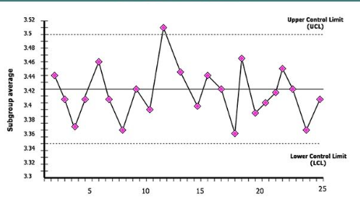

# 7. 4 Blockers PPT

* The main theme of the 4 Blockers ppt is to get high-level understanding of the project.
* A four blocker provides a summary of the most important areas of a project.

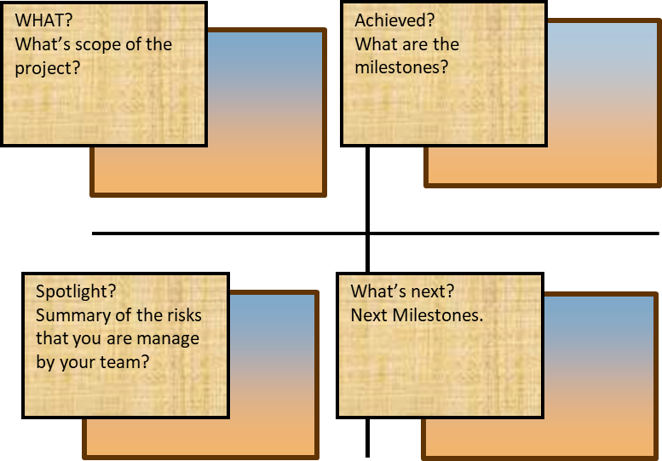

Overview:

1) a description of what's the scope of the project (WHAT)

2) a list of the milestones achieved (ACHIEVEMENTS)

3) a summary of the risks and the opps you have identified and you are managing with the team (SPOTLIGHT)

4) an outlook on the next milestones (WHAT'S NEXT).

# 8. SDLC PROCESS - V MODEL

SDLC Process---------> **Software Development Life-cycle Process**

* Software Development Life Cycle (SDLC) is a process used by the software industry to design, develop and test high quality softwares.

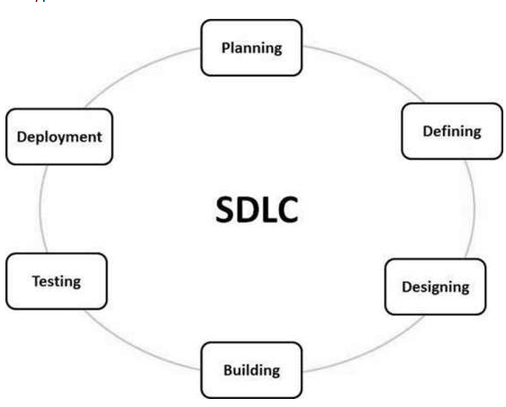

* In SDLC we have different models, But SRM follows V- Model SDLC.
* V- model is a type of SDLC where a process executes in sequential manner in a V- shape.
* It is also known as a verification and validation model.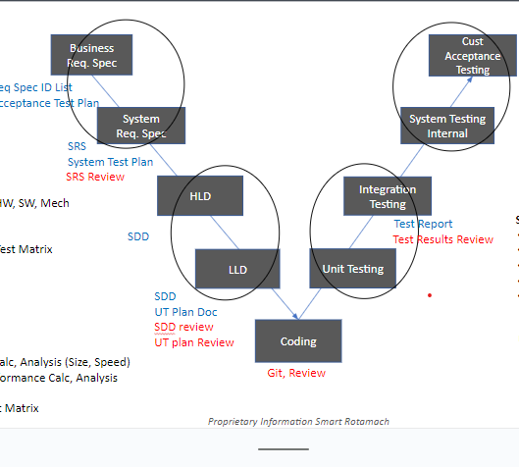
* Study Flow of SDLC
* SRS—SDD—STP— STR
* SPRINT: A dedicated period of time in which a set of work will be completed
* Defect Management Process:
* Report any defect before the customer detects it.
* Defect Discovery,Report defect,Accept Defect.

## 8.1 Defect verification

* Retest and report it
* Defects can be rejected as defects by the designer, so the product owner is responsible to decide it as a defect or false.